**CSE211 Web Programming, Fall Semester 24/25**

**Assignment #1: Websites conceptual Design and mock-up**

**Mostafa Wael Hamdy Elsaeed , 222101624, Cybersecurity**

**2.3.1: Research.**

World Wide Web had developed from the quite simple static pages of Web 1.0 to the more complex smart automated environment of Web 4.0. Each stage brought innovations that enhanced the digital landscape, improving the methods of information sharing, interacting with other people, and utilizing information.

**Web 2.0: The Social Web:**

Around the beginning of the twenty-first century, the second stage- the Web 2.0 stage appeared. With the development of Web 2.0 platforms, users’ ability to engage with the platform expands from merely viewing to creating and participating in the community. Key features of Web 2.0 are social networking, interactive and content-based user-generated content. Facebook, Twitter, and YouTube are all part of the era where people are active participants in the community by posting content, ideas, and other forms of expression. The network effect, or the ability of a platform to become more helpful with the increase of active users, enabled networks of interlinked users to focus on sharing and communication in major ways. Such user-generated content of blogs, wikis, and forum ecosystems created a participatory environment for knowledge creation and sharing that developed a collaborative and collective intelligence culture (O'Reilly, 2005)

**Web 3.0: The Semantic Web:**

In the 2010s, Web 3.0’s use of artificial intelligence, machine learning, and data analytic technologies augmented the meaning and relevance of data, giving rise to what is known as the ‘Semantic Web’. The Semantic Web focused on the better classification of the information resources that were available on the internet and enabled even machines to comprehend and process information like human beings. The integration of structured data and ontologies in Web 3.0 in turn helps the development of intelligent systems that allow various pieces of information to be linked in ways that provide new understanding (Berners-Lee et al., 2001). This web stage makes it possible to establish information in the form of knowledge graphs, which improves the accuracy and quality of results obtained during searches and enables knowledge to be created from data to benefit various industries including health and finance.

**Web 4.0: The Intelligent Web:**

Web 4.0 is a new generation of the internet which is known as the “Intelligent Web.” Web 4.0 is more centered around interfacing people and machines. Interesting aspects of Web 4.0 occur like decentralized and self-sufficient systems that autonomously make quality decisions through real-time data analysis and critical reasoning. The merger of AI, IoT devices, and robotic technologies advances Web 4.0 to a level where machines can engage people contextually, anticipate their requirements, and respond appropriately. It is within this period that 'intelligent connections' are established that utilize machine learning and big data analytics to enable intelligent systems aimed at creating automated and decision-making processes that are continuously evolving (Fuchs, 2017).

**Collective Intelligence and Social Technologies:**

The use of social tools like social bookmarking, social networks, and social media along with the system and its content has been critical in the development of all web generations, especially from the 2.0 and above. Social media devices use collective around which people develop a shared focus integrated with a diverse set of knowledge, opinions, and behaviors in the markets which enables these trends to emerge and utilized productively. In addition, social bookmarking as exhibited in Reddit, Pinterest, and similar platforms helps to illustrate the role of shared intelligence by allowing users to sort, tag, share, and collaboratively find information.

**Business Implications and Future Outlook:**

These new websites have created new markets and new products for their businesses that were not available before. With the help of Web 2.0 the emphasis was directed on users, and Web 3.0 took the experience to the next level and focused on taking the customers’ likes into account. And with Web 4.0, the prospects look even more promising, as it ensures industries operate based on real-time visualization of data and automated decision-making processes. Companies will be able to develop cutting-edge strategies based on these technologies that are highly interactive and promote user feedback while increasing efficiency and customer satisfaction.

**Personal Application in Cybersecurity:**

As a cybersecurity Engineer, I intend to utilize the Web 4.0 capabilities in the detection and response to threats. In my perspective, Web 4.0 facilitates, among other things, AI and machine learning, which are critical in developing predictive models for seeking and identifying risk factors and impending threats and thus diminishing the responsive period to cyber incidents. It will also be important to use shared threat-intelligent platforms to harness collective intelligence to counter newer attack vectors. A combination of these technologies holds a lot of promise in the creation of resilient and flexible cybersecurity architectures

**2.3.2: Website Planning.**

**1. Define the purpose of your intended website.**

* The purpose of the website is to provide comprehensive information about tourist sites in Egypt, including descriptions, multimedia content (photos, videos), and links to booking platforms to enhance user engagement and tourism.

**2. What would you like the website to accomplish?**

* The website should serve as an informative and user-friendly resource for potential tourists, helping them learn about various sites, see related media, and access booking options easily.

**3. Who is your intended audience?**

* The primary audience includes local and international tourists interested in exploring Egypt, as well as travel agencies looking for a resource to guide their clients.

**4. What opportunities, problems, or issues does your planned website address?**

* The website addresses the need for centralized, reliable, and visually engaging information about Egypt's tourist sites. It solves the problem of scattered information across various sources, enhancing accessibility and ease of planning for tourists.

**5. What kind of content could be incorporated on your website?**

* Content may include written descriptions, historical context, high-quality photos, virtual tours, maps, booking links, visitor reviews, and cultural insights.

**6. How will the site serve the client?**

* The site provides a one-stop platform for clients to discover, explore, and book visits to tourist sites in Egypt, enhancing their trip planning experience and potentially increasing tourism.

**7. What is the best method for the user to do what** **is wanted?**

* Clear navigation, a search feature for specific sites, and interactive elements (like maps and virtual tours) will help users easily find information and book tours.

**8. How will users find the function?**

* Users will access the booking function through prominent call-to-action buttons on each site’s page, or via a dedicated booking section accessible from the main menu.

**9. How will the results of the function be received?**

* Upon clicking a booking link, users will be redirected to a third-party booking platform, where they can complete the transaction. The website may also track click-through rates for analytics.

**10. What will the receiver do with the received entries?**

* As entries are managed by the booking platform, the website will primarily analyze user interactions to improve content and layout based on visitor interest.

**11. How will the receiver deal with the results?**

* The third-party booking platforms will handle actual bookings, while the website could use analytics data for improving user experience and marketing.

**12. What follow-up will be needed?**

* Follow-up could include email newsletters with site updates, new tourist locations, and seasonal travel suggestions, along with gathering feedback for continuous improvement.

**13. List at least two related or Similar sites found on the Web. Explain why you chose them.**

* **Example 1**: [Visit Egypt](https://www.egypt.travel/) – This government site provides a detailed look into Egypt’s tourist attractions, serving as a reliable reference for content structure.
* **Example 2**: [TripAdvisor](https://www.tripadvisor.com/) – Known for user reviews and multimedia content, TripAdvisor offers an engaging user experience with booking options, serving as a good example for user interface and functionality integration.

**14. Planning Analysis Sheet:**

a. **Website Goal** - The goal is to create an informative and engaging platform for highlighting Egypt’s tourist attractions. It aims to provide multimedia content, historical insights, and booking options for each location, enhancing user engagement, and supporting tourism.

b. **Working Title**: 1. Destinations, 2. Site Details (for individual tourist sites), 3. Gallery, 4. Reviews, 5. Visa, 6. About us, 7. Contact us.

c. **Content Description for Each Page** - **Homepage**: An introduction to Egypt’s tourism highlights, featuring popular destinations, a search bar, and links to main categories. - **Destinations Page**: Lists major tourist sites categorized by region (e.g., Cairo, Alexandria, Luxor), each with a brief description. - **Site Details Pages** (for each destination): Detailed information about the site, including history, visitor information, photos, videos, and a booking link. - **Gallery**: A multimedia gallery displaying high-quality images and videos of Egypt's tourist attractions. - **Reviews**: A page where users can submit and read reviews of tourist sites. - **Visa**: Links to third-party booking services, categorized by site or activity. - **About Us**: Information about the website’s mission and team. - **Contact Us**: A form for inquiries and feedback, including links to social media.

d. **User Forms for Collecting Information** - Forms could include: - **Registration/Login**: Optional accounts for personalized experiences. - **Comment and Review Submission**: Visitors can share reviews and experiences. - **Subscription**: Newsletter sign-up for updates on sites, events, and travel tips. - **Contact Form**: For user inquiries or support requests.

e.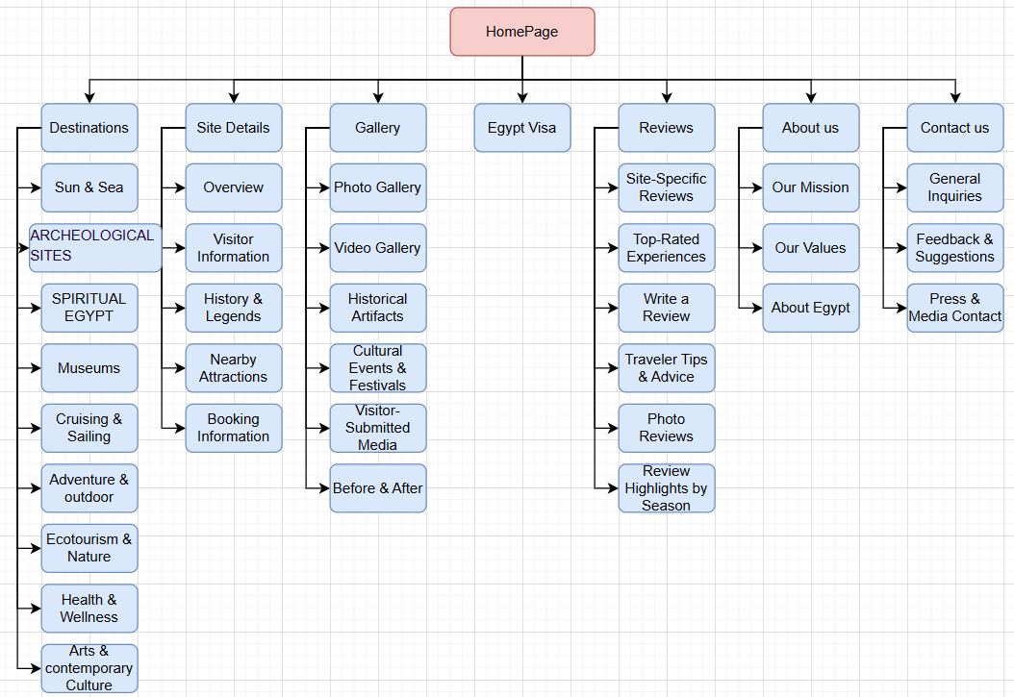

f.1. HomePage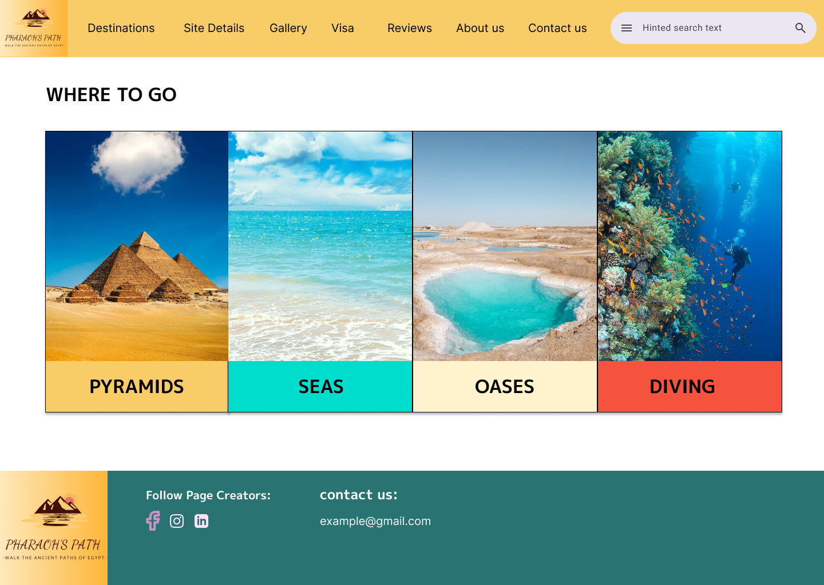

2.Contact us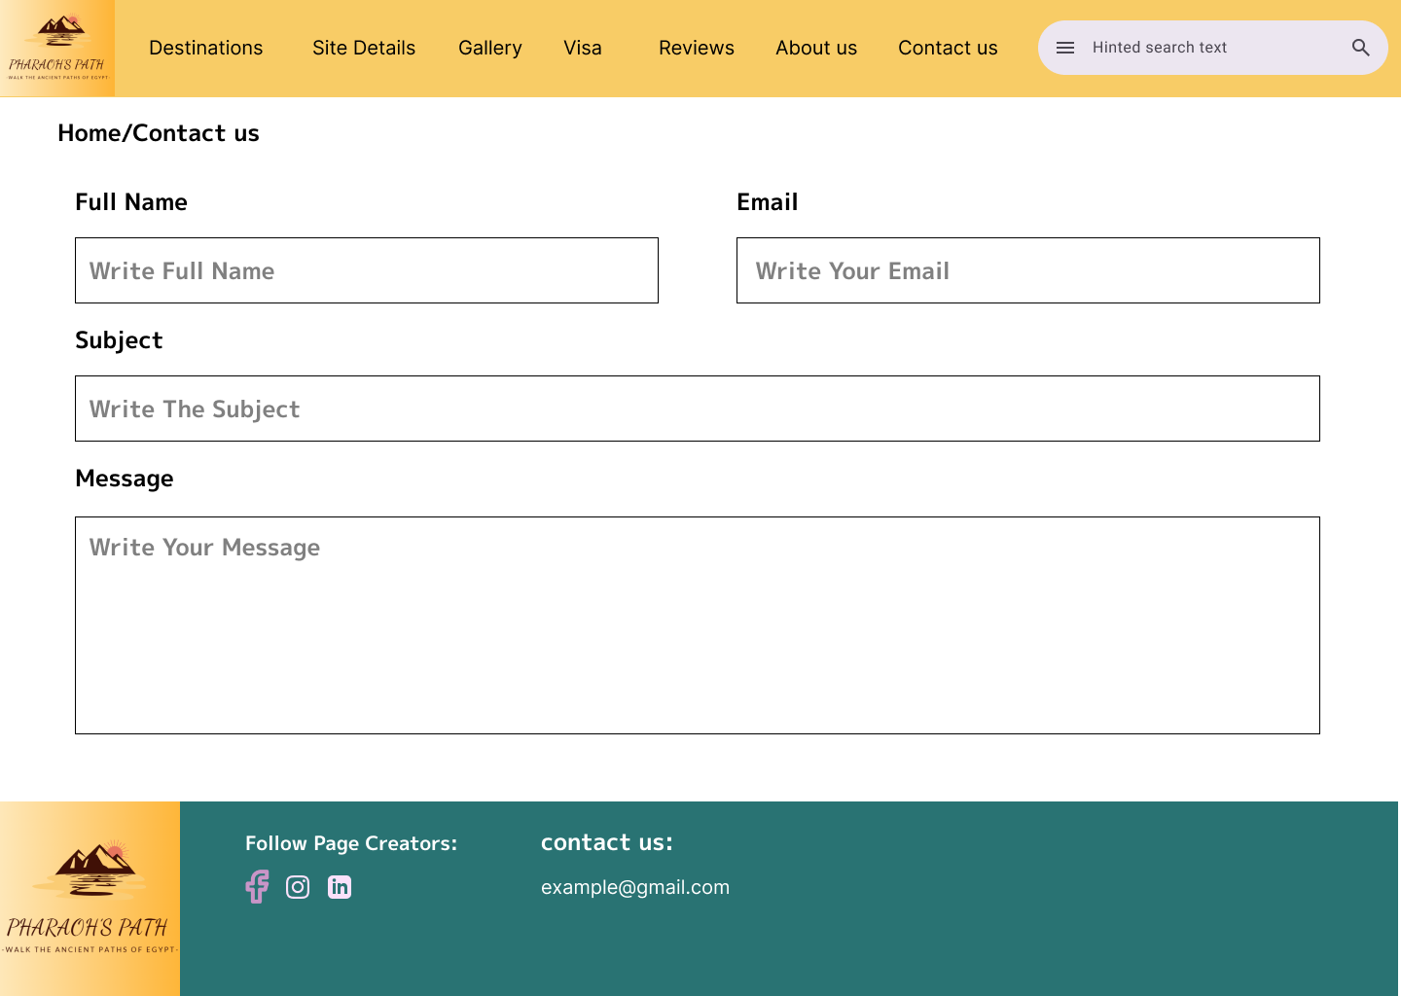

3.About us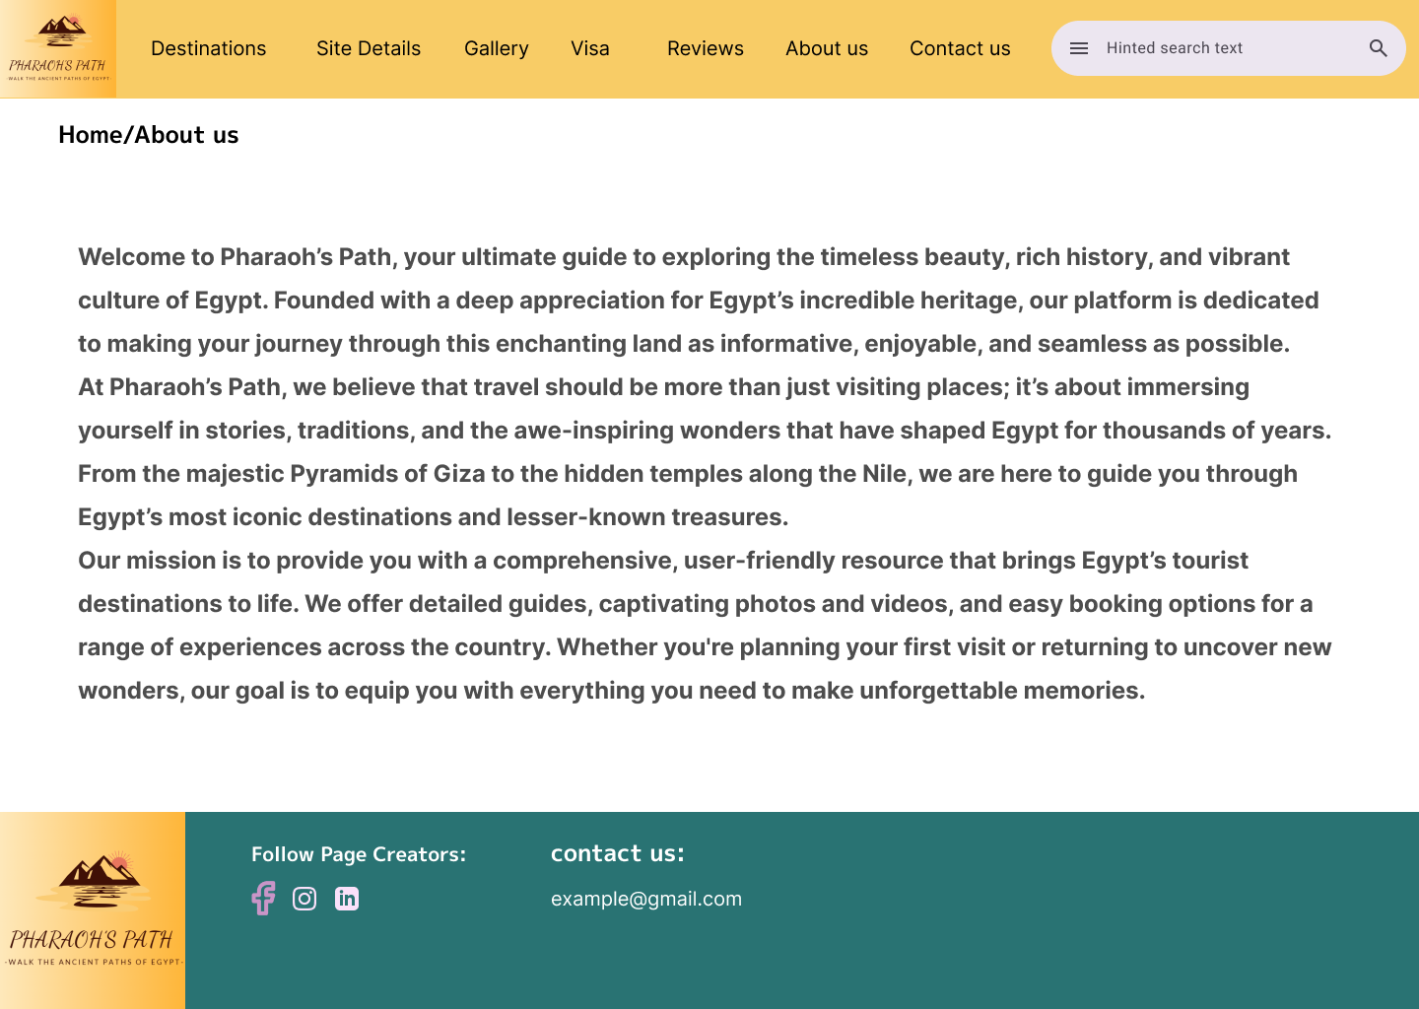

4.Site Details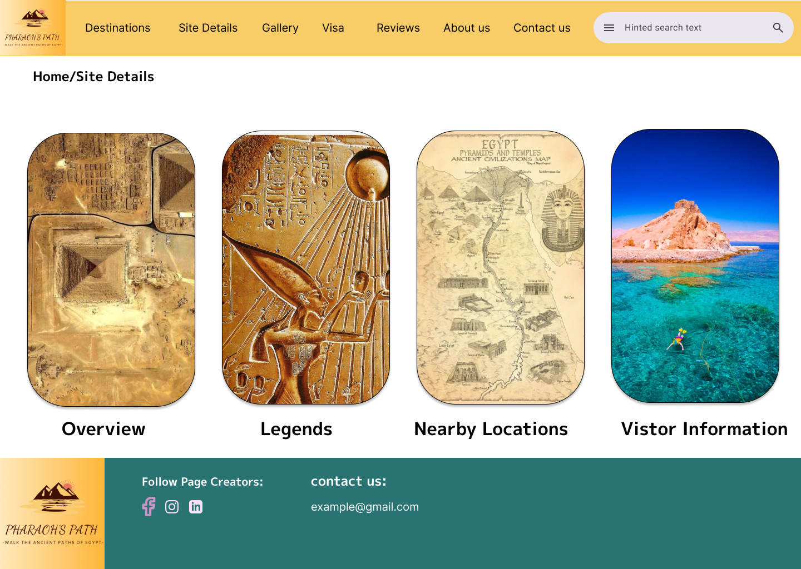

5.Destinations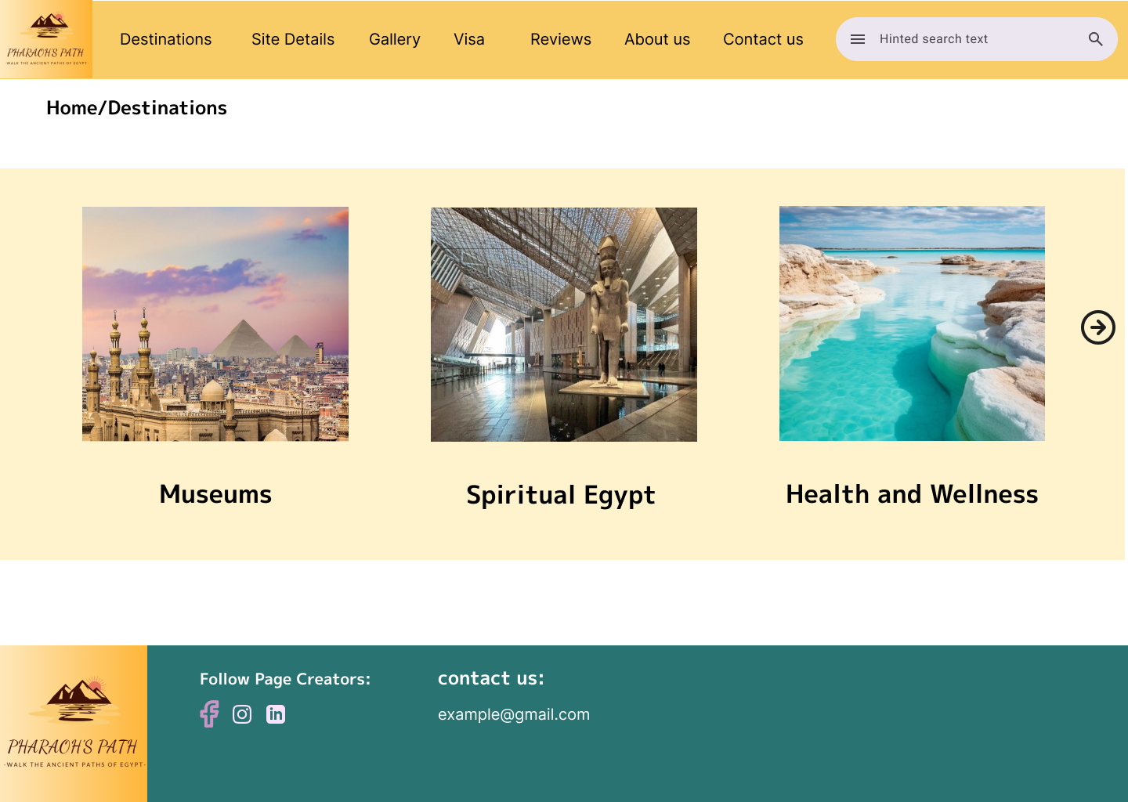

6.Gallery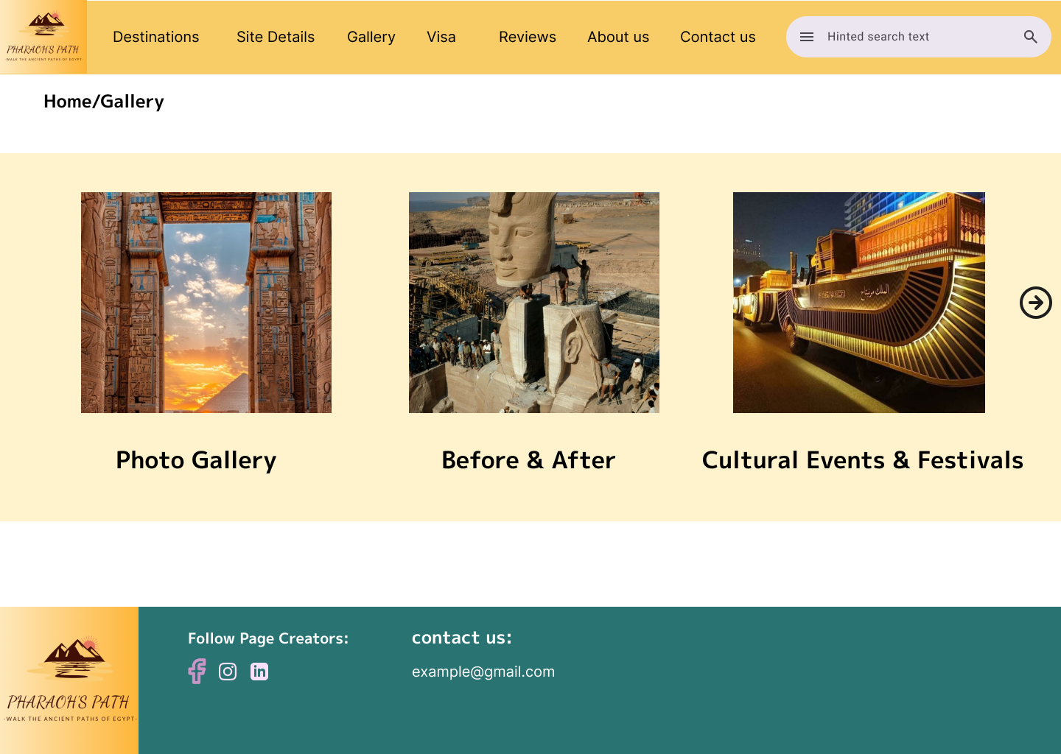

7.Reviews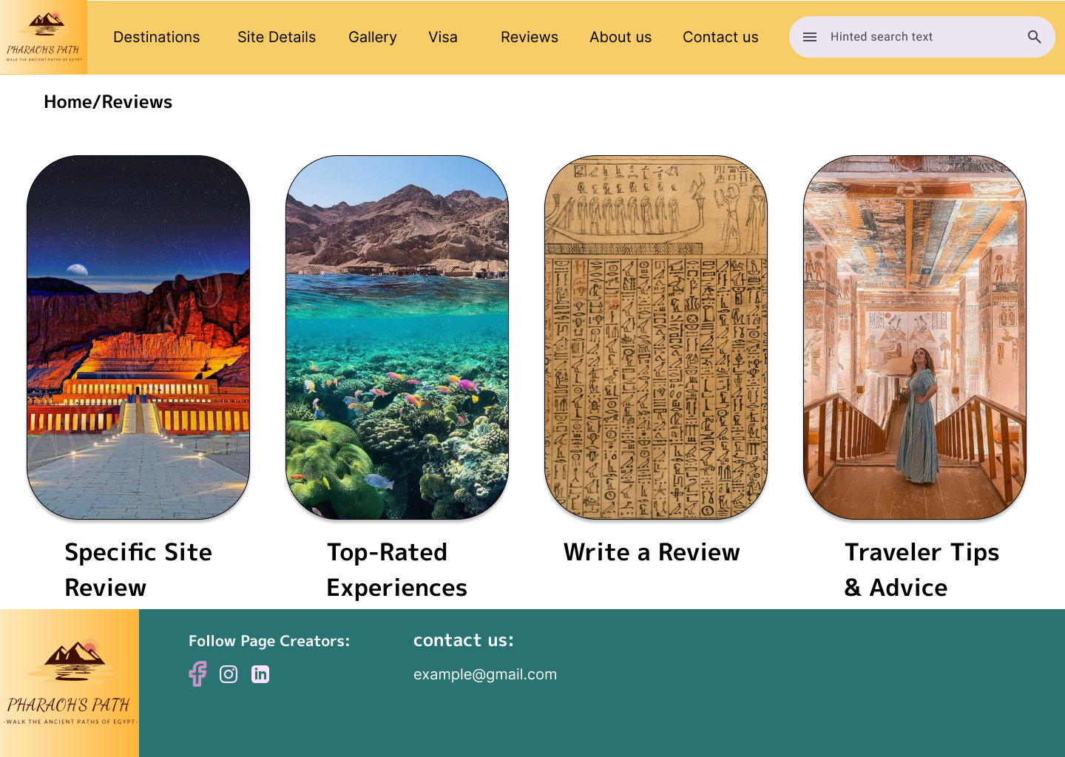

8.Visa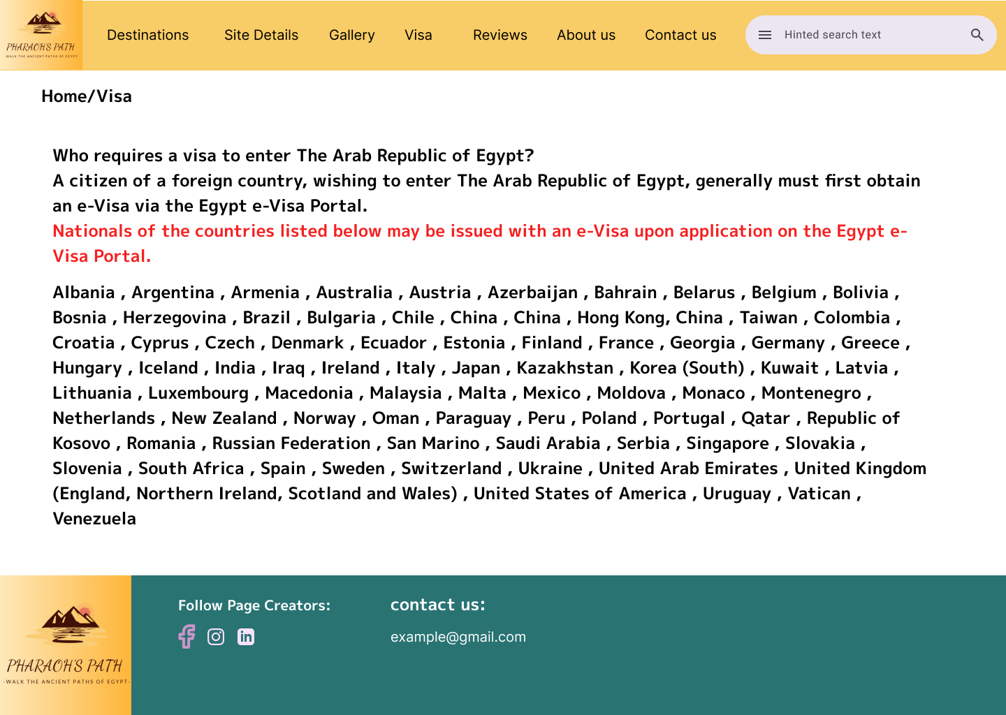

**2.3.3: Website Design.**

**[A]:**

**1. Law of PRÄGNANZ (Good Figure, Law of Simplicity):**

To minimize clutter, each page will feature a clear and simple design with a minor interface. Type, photographs and buttons will be lodged in plain forms such as rectangular boundaries for content blocks to aid in the retention of attention and cognitive effort.

**2. Closure (Link Individual Elements to Form a Pattern):**

We will use pictograms complete with lines and letters. For example, when a lot of pictograms representing distinct tourist sites are encircled in a semicircle, it stimulates curiosity to complete the task by viewing all the site particulars as one.

**3. Symmetry and Order:**

All pages will maintain proportionate layouts. Texts and photos will be presented in the same shape with inner margins so that the major navigation’s and contact forms are located at the middle or evenly spaced positions. This framework allows users to access information within the shortest time possible, and it also encourages order and confidence in the user.

**4. Figure/Ground (Relationship between Positive Elements and Negative Space):**

High-contrast colors and whitespace will help users easily distinguish between interactive elements (buttons, icons) and the background. The pages will place important information in contrasting colors against a neutral background to make it stand out.

**5. Uniform Connectedness (Relationship Between Elements):**

Photos and descriptions of related features will be in card-shaped boxes bordered or marked. For instance, facilities possessed by each site including details, booking and their reviews will be found under interrelated parts.

**6. Common Region (Connection Between Elements):**

Content sections like Destinations and Gallery will have defined backgrounds or borders, creating visual boundaries that connect related elements. This helps users quickly identify and engage with distinct areas on each page.

**7. Proximity (Utilizing Empty Space to Create Relationships):**

Related items like text, icons, and buttons will be grouped closely with appropriate whitespace around them, giving each page a clean look. For example, on the Site Details Page, Site options will be spaced apart, making each tour clearly defined and easy to see.

**8. Continuation (Continuous Perception of Shapes):**

Implementation: Visual elements like borders, lines, and image alignments will guide users' eyes naturally across the page. For example, a horizontal line or series of images on the Gallery Page will encourage continuous scrolling, giving users a smooth navigation experience.

**9. Common Fate (Synchrony):**

Interactive elements like buttons will change color together on hover, creating a synchronized effect that suggests related action. In the Gallery and Destinations pages, images could zoom in or highlight when hovered over in unison, indicating that they belong to the same category or theme.

**10. Parallelism (Parallel Elements are Seen as Related):**

Elements such as text blocks and images will be aligned in parallel rows or columns. For instance, Visitor Reviews on each page will be displayed in a grid with parallel borders, making each review appear equally important and organized.

**11. Similarity (Elements with Similar Characteristics are More Related):**

Icons, buttons, and typography styles will be consistent throughout the website to create familiarity and cohesiveness. For instance, icons for Contact Us and Social Media links will share a similar style, connecting them as navigation tools.

**12.** **Past Experience (Observer's Past Experience):**

The site’s layout and navigation will follow common design patterns familiar to most users, like a top navigation bar and footer with links to important pages. This familiar structure leverages users' past experiences, reducing the learning curve and improving usability.

**[B] Deployment:**

**1.**1440 x 1024

**2.**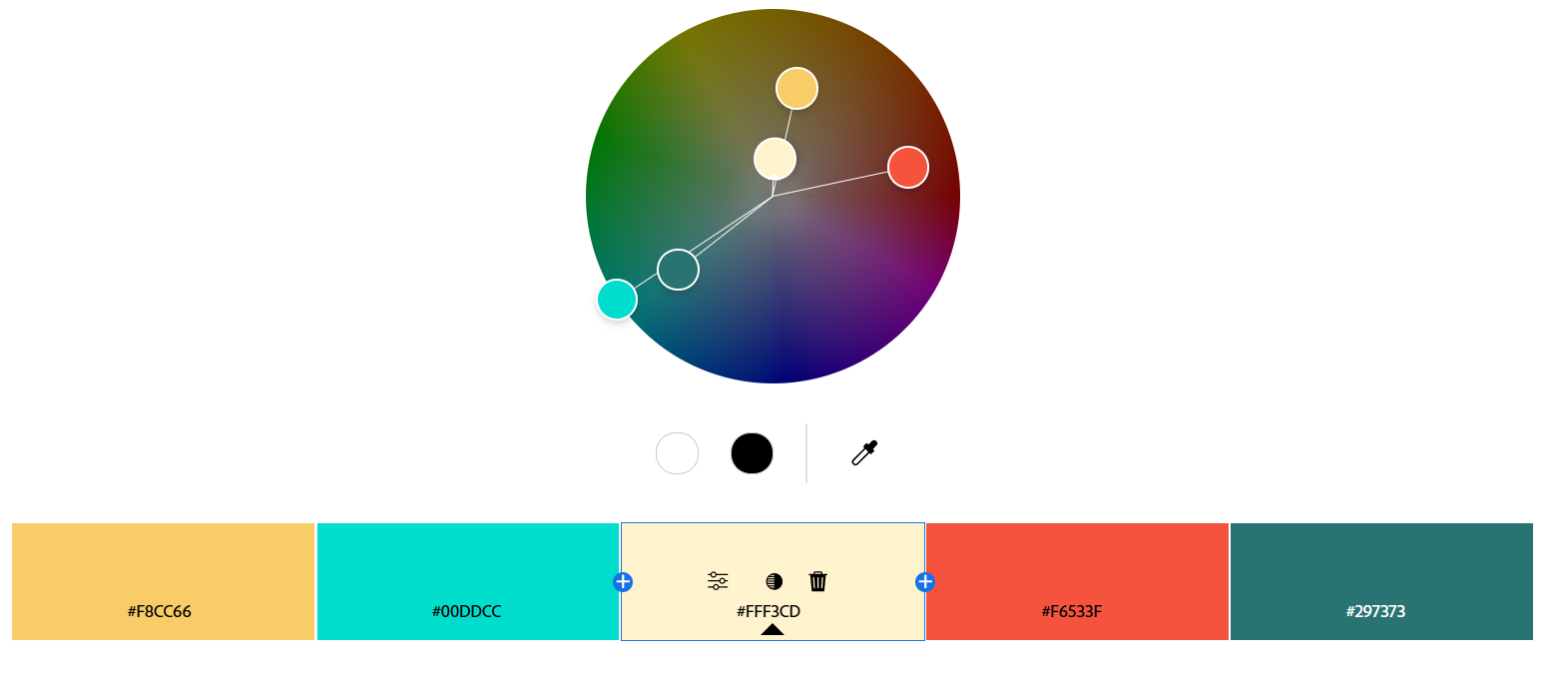

**3.**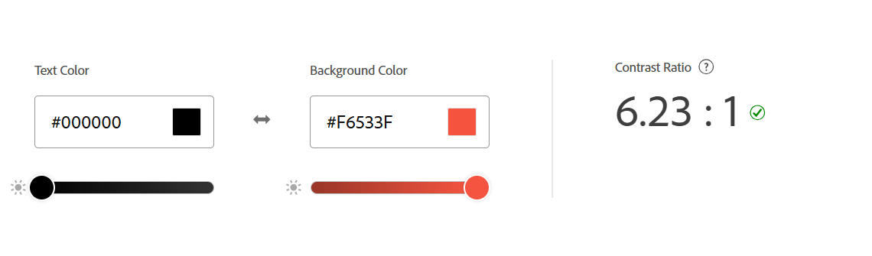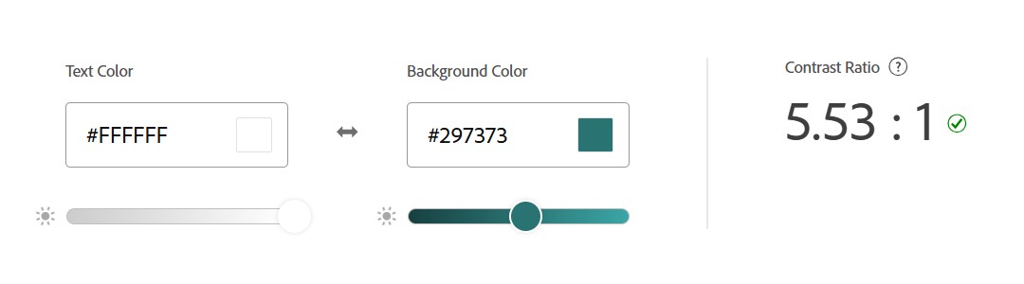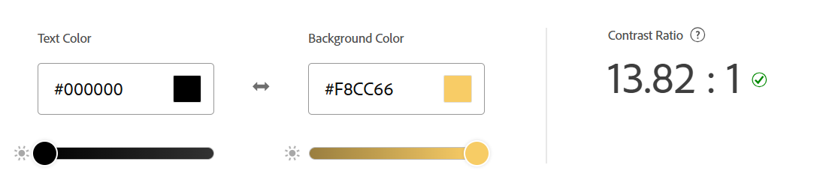

**4. Front-End Development Technologies**

* HTML5/CSS3: For structuring and styling content, providing a responsive design that adapts to various screen sizes.
* JavaScript: Adds interactivity, such as animations, dynamic content loading, and interactive maps**.**

**5. Content Management Systems (CMS)**

* WordPress: Ideal for smaller-scale, quick-to-deploy websites with many available tourism-focused plugins for maps, booking, and galleries.

**6.** **Back-End Development Technologies**

**1. PHP.**

**2. Database**:

* **MySQL**: For structured, relational data if there is a need for handling complex queries and data relationships.

**7. Metrics for Measuring Website Success**

**1. User Engagement:**

* Page Views: To see how many times pages are accessed, helping identify popular content.
* Average Session Duration: To understand how long users are spending on the site.
* Bounce Rate: To monitor how often visitors leave without interacting, which could indicate issues with content or user flow.

**2. User Interaction:**

* Click-Through Rate (CTR) on Booking Links: To measure how often users proceed to booking platforms, a key success indicator.
* Conversion Rate: Track the percentage of users who complete desired actions, such as booking, subscribing to a newsletter, or leaving a review.

**Content Popularity:**

* Most Viewed Pages: Identifying which tourist sites or content sections receive the most attention.
* Social Shares: Tracking how often pages or images are shared, indicating user interest and social reach.

**3. User Feedback:**

* Review Ratings and Comments: User reviews can reveal satisfaction levels and areas for improvement.
* Net Promoter Score (NPS): For gauging overall user satisfaction and likelihood to recommend.

**4. Technical Performance:**

* Page Load Time: To ensure fast loading speeds, especially critical for a multimedia-rich site.
* Mobile vs. Desktop Use: Insights on device usage can inform mobile responsiveness improvements.
* Error Rate: Monitoring broken links, failed requests, and other errors to improve the user experience.

**8.Html structure code for every page:**

**1.HomePage:**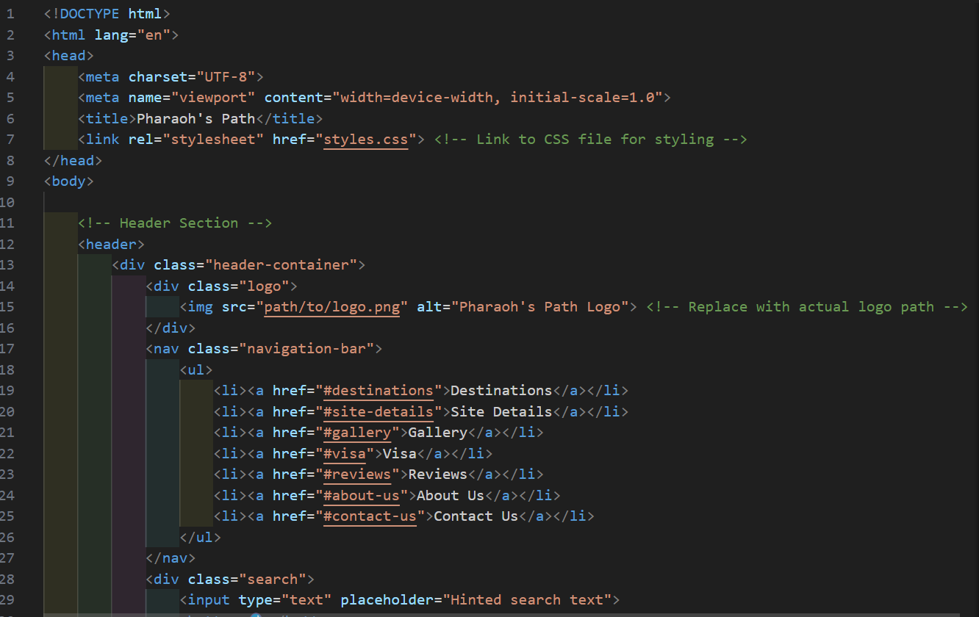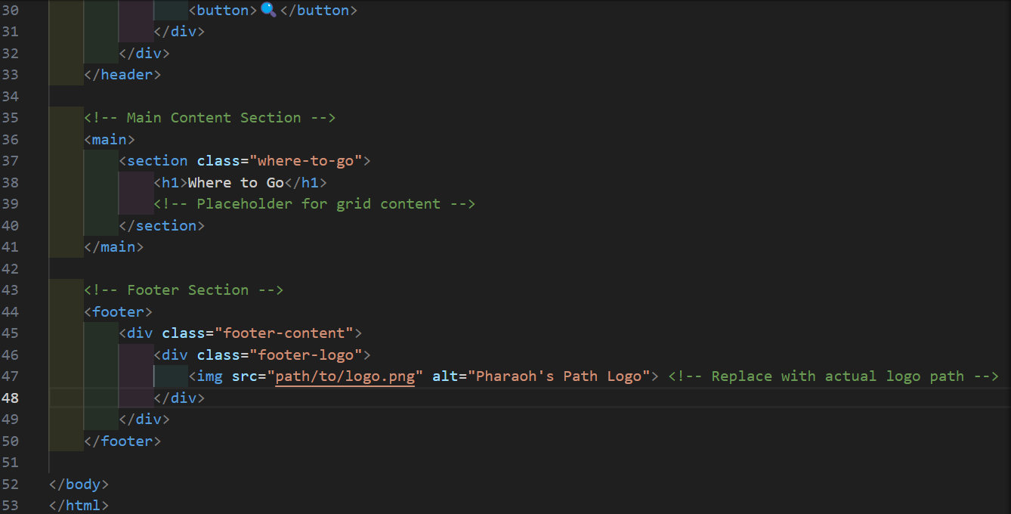

**2.Contact us Page:**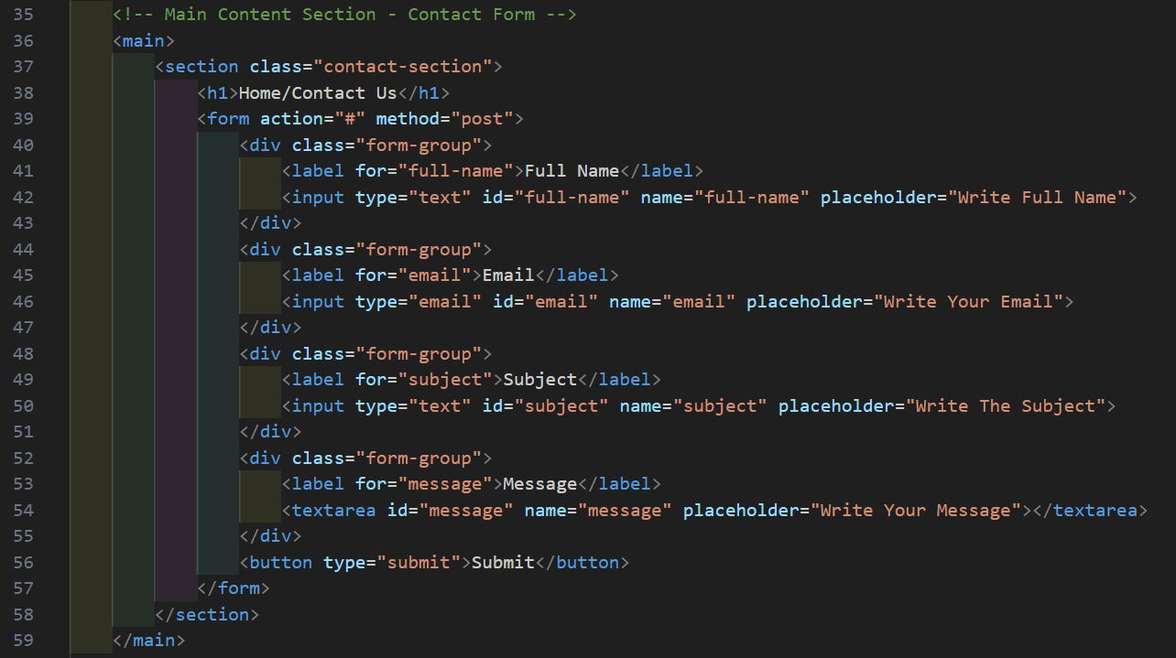

**3.About us Page:**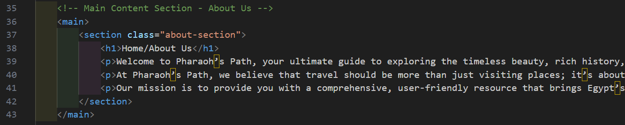

**4.Site Details Page:**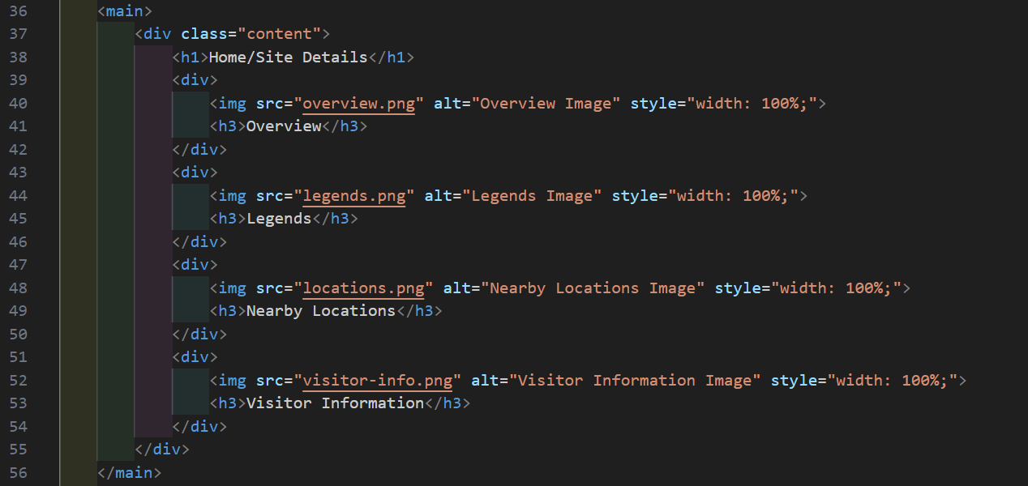

**5. Destinations Page:**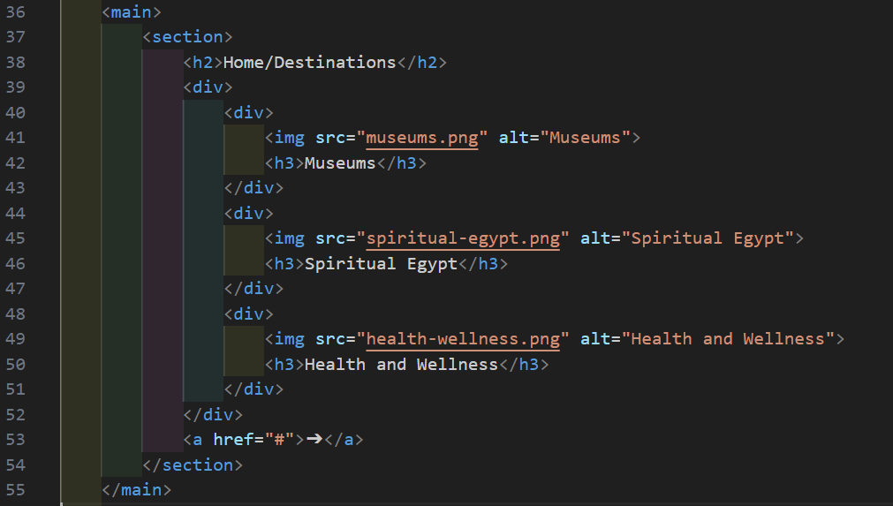

**6.Gallery Page:**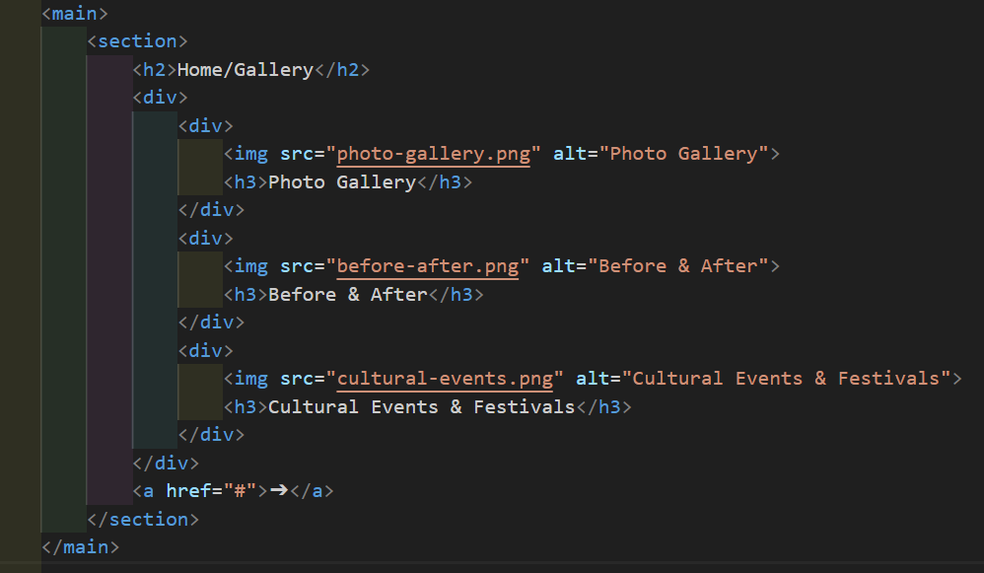

**7.Reviews Page:**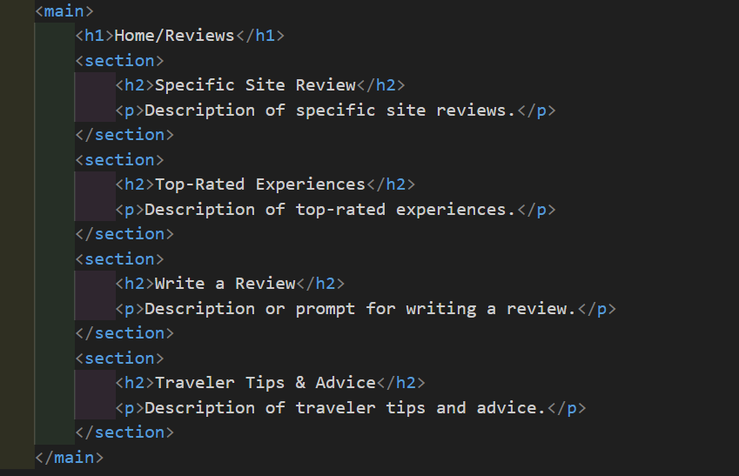

**8.Visa:**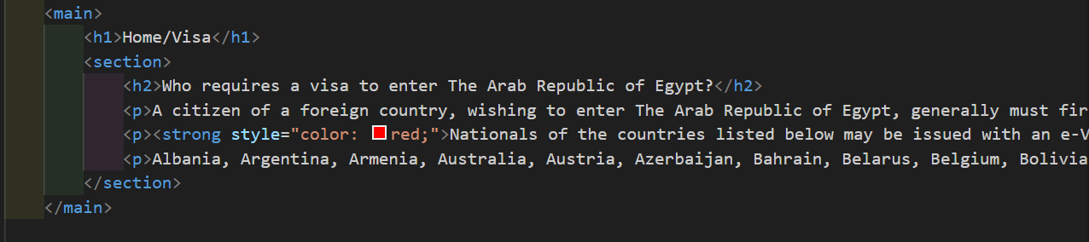

**Note:** All pages have the same header and footer and navigation bar as on the homepage.

**Plagiarism Report:**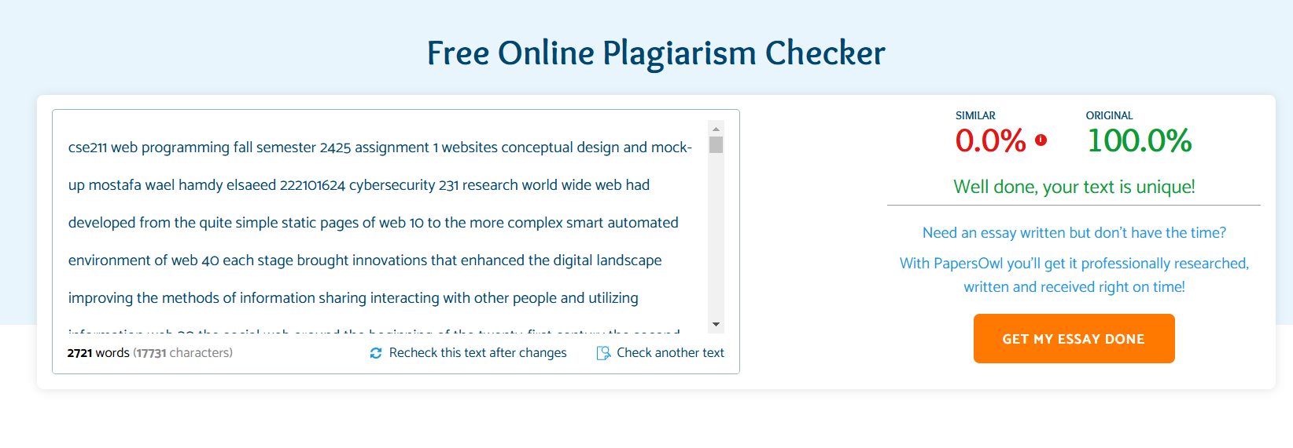

**Note:** This check was made using PapersOwl

**References:**

[1] D. Heeger, *Gestalt principles of perception*. Stanford University, 1998. Available: <https://web.stanford.edu/class/psych209/Readings/Heeger-Gestalt.pdf>.

[2] S. Law, "Applying Gestalt Principles to Web Design," *Smashing Magazine*, 2020. Available: <https://www.smashingmagazine.com/2020/04/applying-gestalt-principles-ui-design/>.

[3] T. Berners-Lee, J. Hendler, and O. Lassila, "The Semantic Web," *Scientific American*, vol. 284, no. 5, pp. 28-37, 2001. Available: <https://www.scientificamerican.com/article/the-semantic-web/>.

[4] C. Fuchs, *Social Media: A Critical Introduction*. Sage, 2017. Available: <https://us.sagepub.com/en-us/nam/social-media-a-critical-introduction/book248520>.

[5] T. O'Reilly, "What Is Web 2.0: Design Patterns and Business Models for the Next Generation of Software," 2005. Available: <http://www.oreilly.com/pub/a/web2/archive/what-is-web-20.html>.

[6] Databox Blog, "21 Website Metrics Every Business Should Track," 2023. Available: <https://databox.com/website-metrics>.

[7] Google Analytics Academy, *Introduction to Data Analytics for Business*. Google Analytics. Available: <https://analytics.google.com/analytics/academy/>.

[8] S. Tilkov and S. Vinoski, "Node.js: The JavaScript Runtime That Lets You Build Fast, Scalable Network Applications," *IEEE Internet Computing*, vol. 14, no. 6, pp. 80-83, 2010. Available: <https://ieeexplore.ieee.org/document/5678247>.

[9] MDN Web Docs, "Django Overview." Mozilla. Available: <https://developer.mozilla.org/en-US/docs/Learn/Server-side/Django>.

[10] S. Sharma, "Choosing the Right CMS for Your Website," *Contentful Blog*, 2021. Available: <https://www.contentful.com/r/knowledgebase/choosing-the-right-cms/>.

[11] MDN Web Docs, *HTML, CSS, and JavaScript documentation*. Mozilla. Available: <https://developer.mozilla.org/en-US/docs/Web>.

[12] Visit Egypt, "Welcome to Egypt," 2023. Available: [https://www.egypt.travel](https://www.egypt.travel/).

[13] TripAdvisor, "Things to Do in Egypt," 2023. Available: <https://www.tripadvisor.com/Tourism-g294200-Egypt-Vacations.html>.

[14] PapersOwl, "Free Plagiarism Checker," 2023. Available: <https://papersowl.com/free-plagiarism-checker>.

[15] Figma, "HomePage Design," 2023. Available: <https://www.figma.com/design/5fTlOrmMdKYww5dsyJhDwo/HomePage?node-id=0-1&node-type=canvas&t=5VUNJC8INxxwqr5j-0>.